PROJECT REPORT ON

**NAME OF THE PROJECT IN CAPITAL LETTERS**

BY

**(NAME OF THE STUDENTS IN CAPITAL LETTER)**

**UNDER THE GUIDENCE OF**

**(NAME OF THE PROJECT GUIDE IN CAPITAL LETTER)**

**DEPARTMENT OF ELECTRONICS & TELECOMMUNICATION**

**K.J.SOMAIYA COLLEGE OF ENGINERING,**

**VIDYAVIHAR, MUMBAI-400077.**

**(Autonomous College Affiliated to University of Mumbai)**

**(2017-18)**

**K.J.SOMAIYA COLLEGE OF ENGINERING**,

**VIDYAVIHAR, MUMBAI -400077.**

**(Autonomous College Affiliated to University of Mumbai)**

DEPARTMENT OF ELECTRONICS & TELECOMMUNICATION ENGINEERING

**CERTIFICATE**

This is to certify that the following students of sem VI

• Name of the student 1 (with roll no)

• Name of the student 2 (with roll no)

• Name of the student 3 (with roll No.)

have successfully completed the project titled “ **(Name of the project )**” towards the partial fulfillment of degree of Bachelor of Technology in Electronics and Telecommunications of the University of Mumbai during academic year 2017-18.

---------------------- -------------------------

**EXAMINER 1 EXAMINER 2**

**MiniProject-2 report Format**

**1. Introduction**

This document describes the standard format for project report. Students have to

ensure their reports conform to the required format before submission for

examination.

1. Submit one report per group
2. Report should be spiral bound

**2. REPORT**

**2.1 Text in the report**

The text of the main report shall be spaced 1.5 lines, in TIMES NEW ROMAN font

with size of 12 on A4 size paper. The font size other than 12 is specified where ever

required. Appendices and other manuals can be in single line spacing and in a smaller

font size. Appendices should be kept small and bound together with the main report.

However, user manuals, programmer manuals and bulky data dictionaries should be

avoided. Please consult your project guide if you are unsure which materials you

should include in the main report. The report should be clearly written, and should

include only relevant information. Indeed, the inclusion of too much unnecessary

detail may cause the examiners to doubt whether the students have really learnt how

to distinguish the important issues from the trivial ones.

**2.2 Format**

All project report must be prepared in the following sequence:

1. Front cover
2. Certificate
3. Abstract
4. Table of contents
5. Main report (introduction, schematic/circuit diagram, working/algorithm/flowchart, results, datasheets, conclusion, future work)
6. References (or bibliography)

Some of the important points on the report format are explained in the following subsections.

1. **Abstract Page**

**I**t consists of an abstract of the report of not more than 200 words outlining the project. The

abstract should be comprehensible to readers of the report and enable them to judge the

report’s potential interest. The Keywords and Subject Descriptions should follow

immediately after the abstract in the same page, each with not more than five carefully

selected items. Any suitable word that reflects the nature and content of the project may be

chosen as a keyword. The student should consult the project guide when in doubt on which

keywords and descriptors should be used. (**Do not use the border as shown in sample**

**page.**)

**4) table of contents**

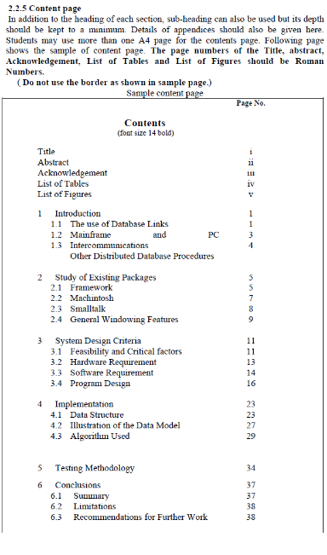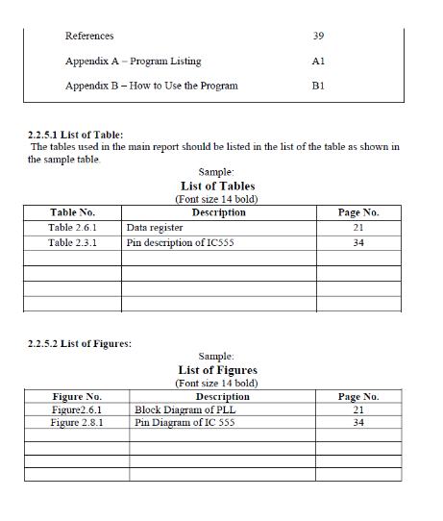

**5) Main report**

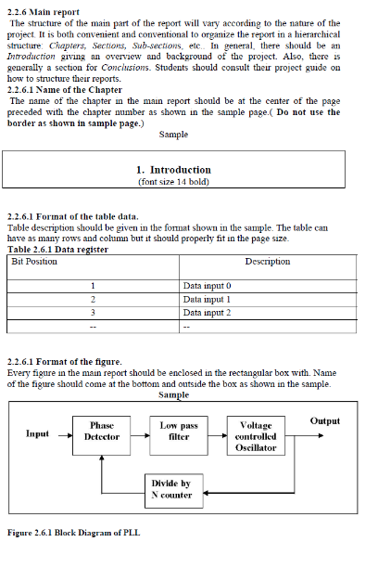**6) References**

A list of all books, report, papers, etc., referred to in the report or consulted during

the course of the project should be given under the References or Bibliography

section. Please see Section 3 for format for references and citation.

**Format for Reference Citation and References**

**6.1 List of References**

References should be ordered alphabetically according to the surname of the first

author (use the editor’s name or the organisation’s name when the author’s name is

absent).

**6.1.1 Journal articles**

Dicken, G.W., Leitheiser, R.L., Wetherbe, J.C. and Nechis, M. (1984) Key

Information Systems Issues for the 1980’s. MIS Quarterly, Vol.8, No. 3, September

1984, pp. 135 – 160.

Gorry, G.A. and Scott-Morton, M.S. (1971). A Framework for Management

Information Systems. Sloan Management Review, Vol.13, No.1, Fall 1971, pp. 55 –

70.

**6.1.2 Books or a report**

Kroeber, D.W and Watson, H.J. (1987). Computer-based information Systems: A

Management Approach. Second Edition, Macmillan Publishing Company, New York,

1987 pp. 152-200.

**6.1.3 Conference paper**

Gouda, M.G. and Dayal, U. (1971). Optimal semijoin schedules for query processing

in local distributed database systems. In Proceedings of ACM SIGMOD International

Conference on the Management of Data, (Ann Arbor, Michican, April 29 – May 1,

1980.) ACM, New York, 1981, pp. 164 – 165.

**6.1.4 Manuals**

IBM. (1984). Information Systems Planning Guide. Fourth Edition, July 1984. SPSS

Inc. (1983). SPSS-X User’s Guide. McGraw Hill Book Company, New York, 1983.

**7) Appendices**

Information of secondary importance (and information whose inclusion would break

the flow of the report) should be placed in Appendices. These include program

listings, electronic data sheets, data dictionary, etc.

**8) Page number and Section number**

All pages in the main report shall be numbered from 1, 2, 3,…. All appendices

should be number as A-1, A-2, etc. for pages under appendix A, and B-1, B-2, etc. for

pages under appendix B. (See the Table of Contents.)

A hierarchical numbering scheme for section numbering shall be used. For instance,

use 1 for section one, 2 for section 2, 1.1 for the subsection 1 of section 1, etc. (See

the Table of Contents.)